+
MediCore
Hospital Management System
─────────────────────────────────
DATABASE MANAGEMENT SYSTEM
CAPSTONE PROJECT REPORT

Submitted By
Aakash Yadav
B.Tech Computer Science & Engineering
KR Mangalam University | 2024 – 2028

Academic Year 2024 – 2028
Subject: Database Management System (DBMS)

Table of Contents

1. | Introduction & Project Overview | 3
2. | System Architecture & Technology Stack | 4
3. | Database Design & Schema | 5
4. | Website Walkthrough — Login & Signup | 7
5. | Website Walkthrough — Dashboard | 8
6. | Website Walkthrough — Patient Management | 9
7. | Website Walkthrough — Doctor Management | 10
8. | Website Walkthrough — Appointment System | 11
9. | Website Walkthrough — Billing System | 12
10. | Website Walkthrough — Prescription System | 13
11. | Website Walkthrough — Room Management | 14
12. | Website Walkthrough — Admission Records | 15
13. | Website Walkthrough — Staff Management | 16
14. | Website Walkthrough — Reports & Analytics | 17
15. | SQL Queries Reference | 18
16. | Setup & Installation Guide | 20
17. | Learning Outcomes & Conclusion | 21

1. Introduction & Project Overview

Project Title: MediCore — Hospital Management System (HMS)
Subject: Database Management System (DBMS)
Student: Aakash Yadav | B.Tech CSE | KR Mangalam University
Technology: MySQL, HTML5, CSS3, JavaScript
Database: Relational Database (RDBMS) with 11 tables

1.1 Abstract
The Hospital Management System (HMS) is a comprehensive database-driven web application designed to manage and streamline the complete operations of a healthcare facility. The system covers patient registration, doctor management, appointment scheduling, billing, prescription tracking, room allocation, staff management, and detailed reporting — all managed through a clean, interactive web interface connected to a structured relational database.
Traditional hospital systems rely heavily on manual paperwork, which leads to data redundancy, errors, and difficulty in retrieving information. This project solves these problems using a Relational Database Management System (RDBMS) built with MySQL, ensuring data consistency, referential integrity, and efficient query performance.

1.2 Problem Statement
Manual hospital record-keeping creates multiple operational challenges:
- Data redundancy: Same patient information repeated across departments
- Inconsistency: Updates in one register not reflected in others
- Slow retrieval: Finding a patient's history requires searching physical files
- Scheduling conflicts: No centralized appointment system
- Financial gaps: Bills and payment status tracked manually without reports
- No real-time visibility: Administrators cannot see room occupancy or pending bills instantly

1.3 Objectives
- Design a normalized relational database with 11 tables covering all hospital modules
- Implement 20+ SQL queries for comprehensive data retrieval and reporting
- Build an interactive web-based frontend with full CRUD operations
- Add user authentication with login and signup functionality
- Provide search functionality across every data module
- Demonstrate real-world application of DBMS concepts: normalization, JOINs, aggregation

2. System Architecture & Technology Stack

2.1 Technology Stack
Layer | Technology / Details
Frontend — UI | HTML5, CSS3, Vanilla JavaScript
Styling | Custom CSS with CSS Variables, Google Fonts (Syne + DM Sans)
Database | MySQL — Relational Database with 11 normalized tables
Data Layer (Demo) | Browser localStorage — simulates SQL persistence for frontend
Architecture | Multi-page SPA (Single Page Application) with JS-driven navigation
Authentication | Custom login/signup with localStorage-based session management

2.2 System Modules
Module | Functionality
Auth System | Login/Signup with email or phone, password validation, session handling
Dashboard | Live stats, recent appointments, pending bills, room occupancy, quick actions
Patients | Register, search, view, delete patient records with full details
Doctors | Add doctors with specialization and department mapping
Appointments | Book and track appointments with patient-doctor linking and status
Billing | Generate bills, track Paid/Pending status, revenue summary
Prescriptions | Link medicines to patients via doctors with quantity tracking
Rooms | Visual grid of rooms, toggle Available/Occupied by clicking
Admissions | Admit/discharge patients to rooms with date tracking
Staff | Manage hospital staff with role categorization
Reports | 20 SQL queries: full hospital report, analytics, summaries

3. Database Design & Schema

3.1 ER Relationships
patients → appointments : One-to-Many (1 patient has many appointments)
doctors → appointments : One-to-Many (1 doctor handles many appointments)
patients → billing : One-to-Many (1 patient has many bills)
patients → prescriptions : One-to-Many (1 patient has many prescriptions)
doctors → prescriptions : One-to-Many (1 doctor gives many prescriptions)
patients → admissions : One-to-Many (1 patient has many admissions)
rooms → admissions : One-to-Many (1 room used in many admissions)
doctors ↔ departments : Many-to-Many via doctor_department table

3.2 All 11 Tables
Table Name | Primary Key | Foreign Keys | Purpose
patients | patient_id | — | Stores all patient records
doctors | doctor_id | — | Stores doctor profiles
departments | department_id | — | Hospital departments list
doctor_department | id | doctor_id, department_id | Maps doctors to departments (M:M)
appointments | appointment_id | patient_id, doctor_id | Scheduled appointments
billing | bill_id | patient_id | Patient billing records
medicines | medicine_id | — | Medicine catalog with prices
prescriptions | prescription_id | patient_id, doctor_id, medicine_id | Doctor prescriptions
staff | staff_id | — | Hospital staff records
rooms | room_id | — | Hospital room inventory
admissions | admission_id | patient_id, room_id | Patient admission records

3.3 Sample SQL: Create Tables
CREATE DATABASE hospital_db;
USE hospital_db;

CREATE TABLE patients (
patient_id INT PRIMARY KEY AUTO_INCREMENT,
name VARCHAR(100) NOT NULL,
age INT CHECK (age > 0),
gender VARCHAR(10),
phone VARCHAR(15) UNIQUE,
address TEXT
);

CREATE TABLE appointments (
appointment_id INT PRIMARY KEY AUTO_INCREMENT,
patient_id INT,
doctor_id INT,
appointment_date DATE,
appointment_time TIME,
status VARCHAR(20),
FOREIGN KEY (patient_id) REFERENCES patients(patient_id),
FOREIGN KEY (doctor_id) REFERENCES doctors(doctor_id)
);

4. Website Walkthrough — Login & Signup

4.1 Login Page
The Login page is the entry point to the MediCore HMS application. It features a professional two-panel layout: a dark teal branded left panel with feature highlights, and a clean white right panel with the authentication form.

Key Features of the Login Page:
- Split-screen layout — left panel shows hospital branding and key features
- Sign In tab — accepts Email or Phone number with password
- Password visibility toggle — show/hide password button
- Default admin credentials — admin@medicore.com / admin123
- Error message displayed for invalid credentials
- Switch to Sign Up link at the bottom

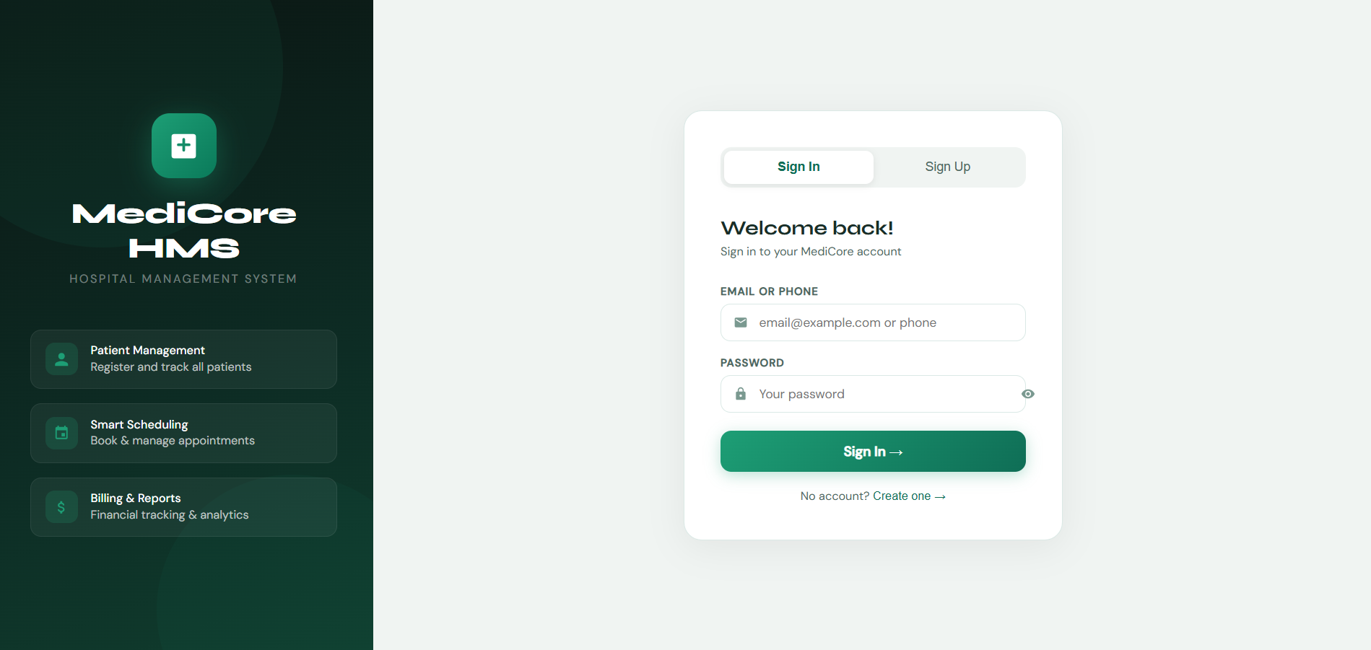
Figure 4.1 — Login Page showing the sign-in form with the branded left panel

4.2 Signup Page
New users can create an account by clicking 'Sign Up' on the auth screen. The registration form collects Full Name, Email, Phone Number, and Password. All fields are validated — password must be at least 6 characters, and duplicate email/phone is rejected. On successful registration, a confirmation message appears and the user is redirected to Sign In.

Key Features of the Signup Page:
- Full Name, Email, Phone, and Password fields with validation
- Password show/hide toggle for better user experience
- Duplicate email/phone detection with error message
- Auto-redirect to Login tab on successful registration
- Responsive design adapts to all screen sizes

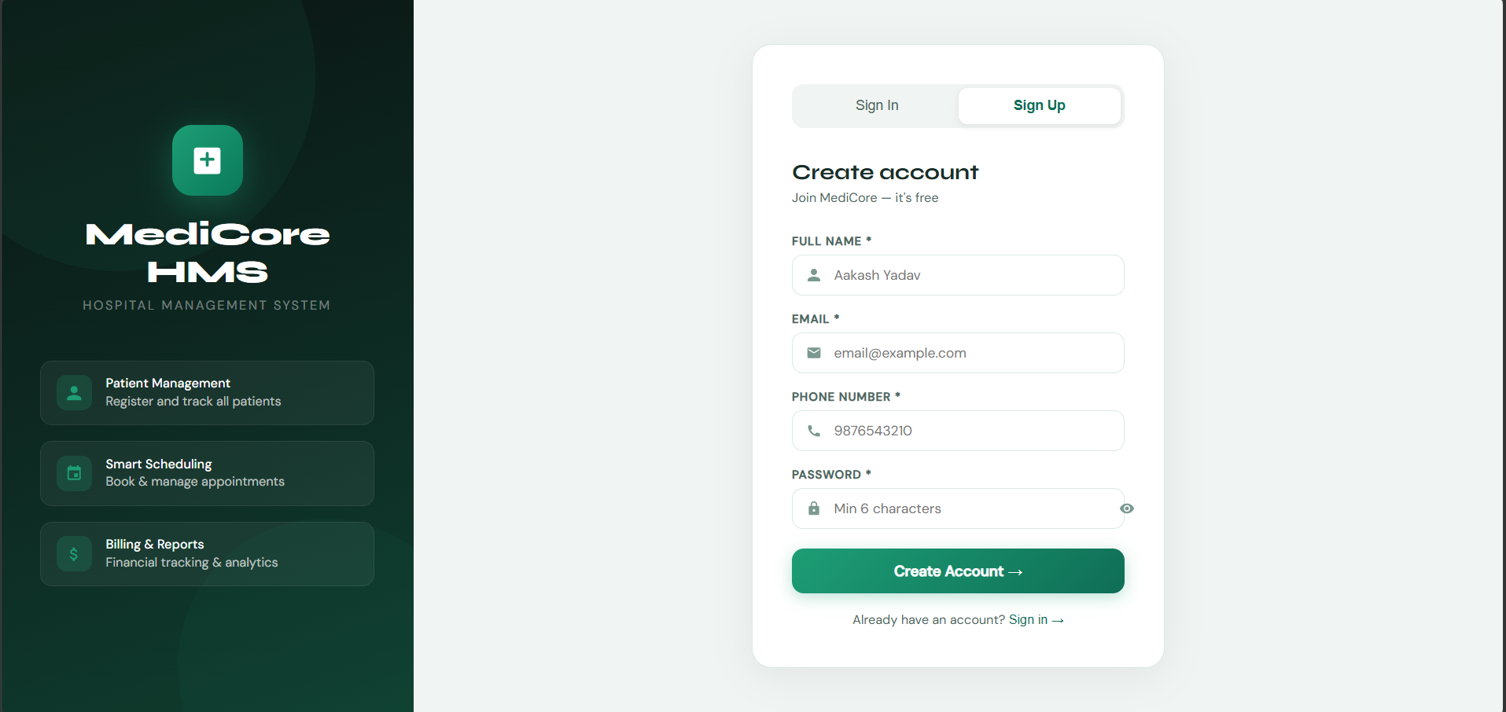
Figure 4.2 — Signup Page showing the account creation form

5. Website Walkthrough — Dashboard

5.1 Dashboard Overview
The Dashboard is the main control center of MediCore HMS. It provides an at-a-glance overview of the entire hospital system after successful login. The layout features a fixed left sidebar for navigation, a sticky top bar with the page title and system status, and a content area with dynamic statistics and widgets.

Dashboard Components:
- Stat Cards (top row) — Total Patients, Total Doctors, Appointments, Revenue, Rooms, Staff — all live-updating from the database
- Recent Appointments — shows last 4 bookings with patient avatar, doctor name, date, and color-coded status badge
- Pending Payments — lists all unpaid bills with patient name and amount due
- Room Occupancy — animated progress bar showing occupied vs available rooms with percentage
- Billing Summary — shows total paid revenue vs pending amount side by side
- Quick Actions — buttons to instantly navigate to New Patient, New Appointment, and New Bill forms
- Sidebar navigation — all 10 sections accessible, with active page highlighted in teal
- Logout button — in the bottom of sidebar, logs out and returns to login screen

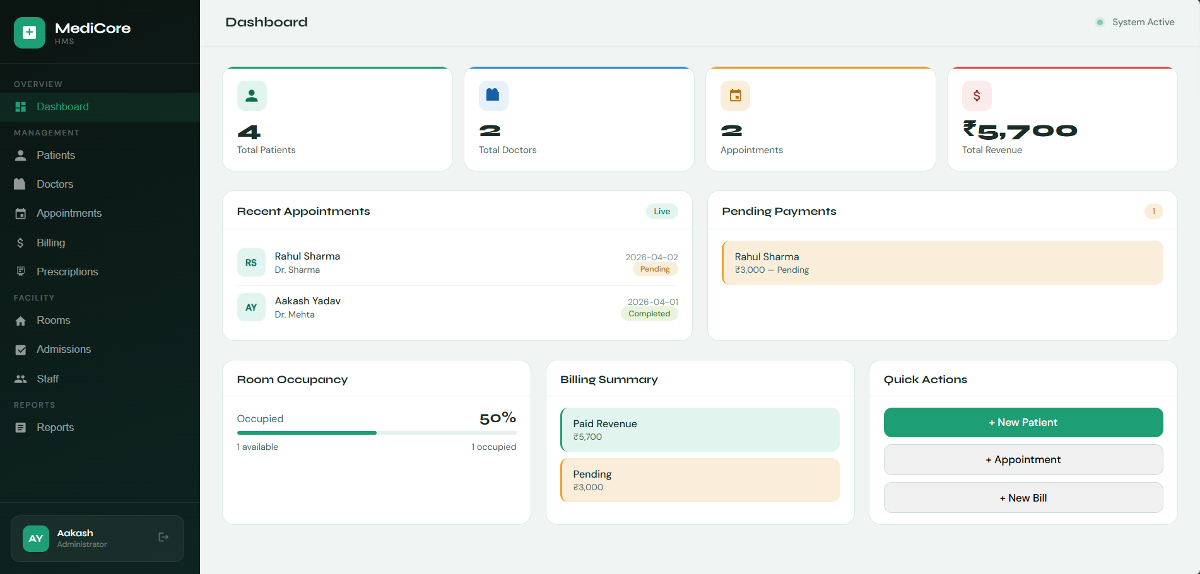
Figure 5.1 — Dashboard showing live statistics, recent appointments, room occupancy, and quick actions

The stats update automatically every time data is added or deleted across any module. The pulsing green dot in the top-right corner indicates the system is active.

6. Website Walkthrough — Patient Management

6.1 Patient Module Overview
The Patient Management module handles complete patient lifecycle management. It is divided into two sections: a registration form at the top and a searchable data table below. This module directly corresponds to the 'patients' table in the MySQL database.

6.1.1 Register New Patient Form
- Fields: Full Name, Age, Phone (required), Gender (dropdown), Address (textarea)
- Validation: All required fields checked, duplicate phone numbers rejected
- Save Patient button triggers INSERT INTO patients SQL operation
- Clear button resets all form fields

6.1.2 Patients Table
- Displays all registered patients with: serial number, avatar initials, name, age, gender badge, phone, address, and delete button
- Gender shown as colored badge — Blue for Male, Red for Female
- Search bar — real-time filtering by patient name or phone number
- Delete button triggers confirmation modal before removing the record
- Row hover effect highlights the record for easy reading

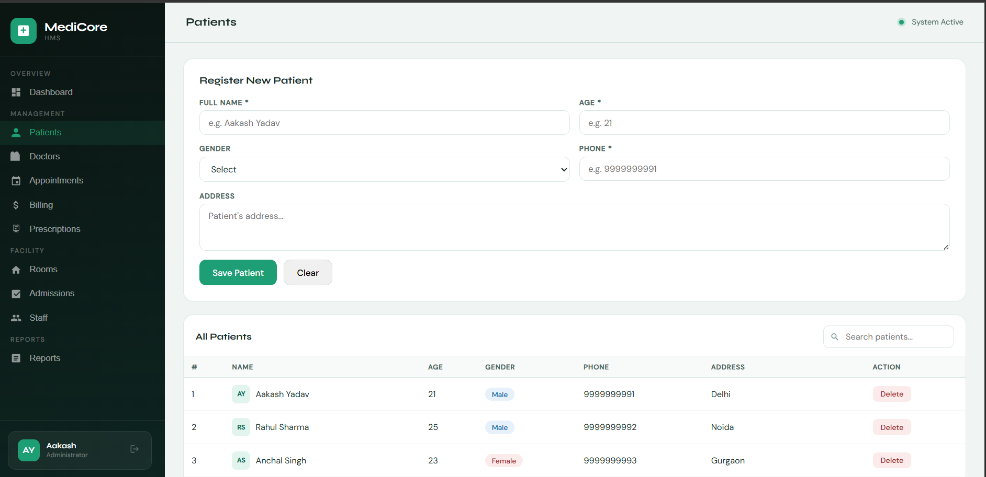
Figure 6.1 — Patient Management page showing the registration form and patient data table with search

7. Website Walkthrough — Doctor Management

7.1 Doctor Module Overview
The Doctor Management module allows administrators to add and manage doctor profiles. Doctors are linked to departments through a many-to-many mapping table (doctor_department) in the database. Each doctor has a specialization that appears as a colored badge in the table.

Doctor Module Features:
- Add Doctor form: Name, Specialization, Department (dropdown from departments table), Phone
- Department dropdown dynamically populated from the departments table
- Doctors table: shows name in bold, specialization as a blue badge, department, phone, and delete option
- Search bar: filter doctors by name or specialization instantly
- Specialization badge makes doctor type immediately identifiable

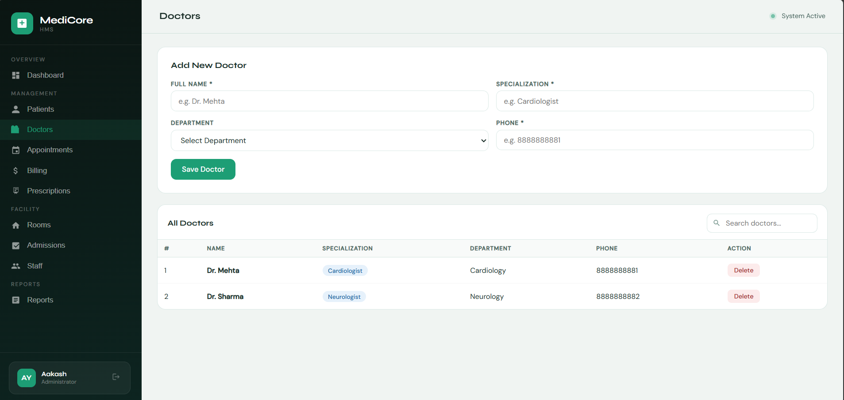
Figure 7.1 — Doctor Management page with add form and searchable doctors table

8. Website Walkthrough — Appointment System

8.1 Appointment Module Overview
The Appointment System is the core scheduling module of the HMS. It links patients to doctors with a specific date, time, and status. This directly maps to the 'appointments' table which has foreign keys to both 'patients' and 'doctors' tables, demonstrating a real-world JOIN relationship.

Appointment Module Features:
- Book Appointment form: Patient (dropdown), Doctor (dropdown), Date picker, Time picker, Status (Pending/Completed/Cancelled)
- Patient and Doctor dropdowns auto-populated from their respective database tables
- Appointments table: columns for patient, doctor, date, time, and color-coded status badge
- Status badges: Green for Completed, Amber/Orange for Pending, Red for Cancelled
- Search bar: filter by patient name, doctor name, or status
- Recent appointments also visible on the Dashboard in real time

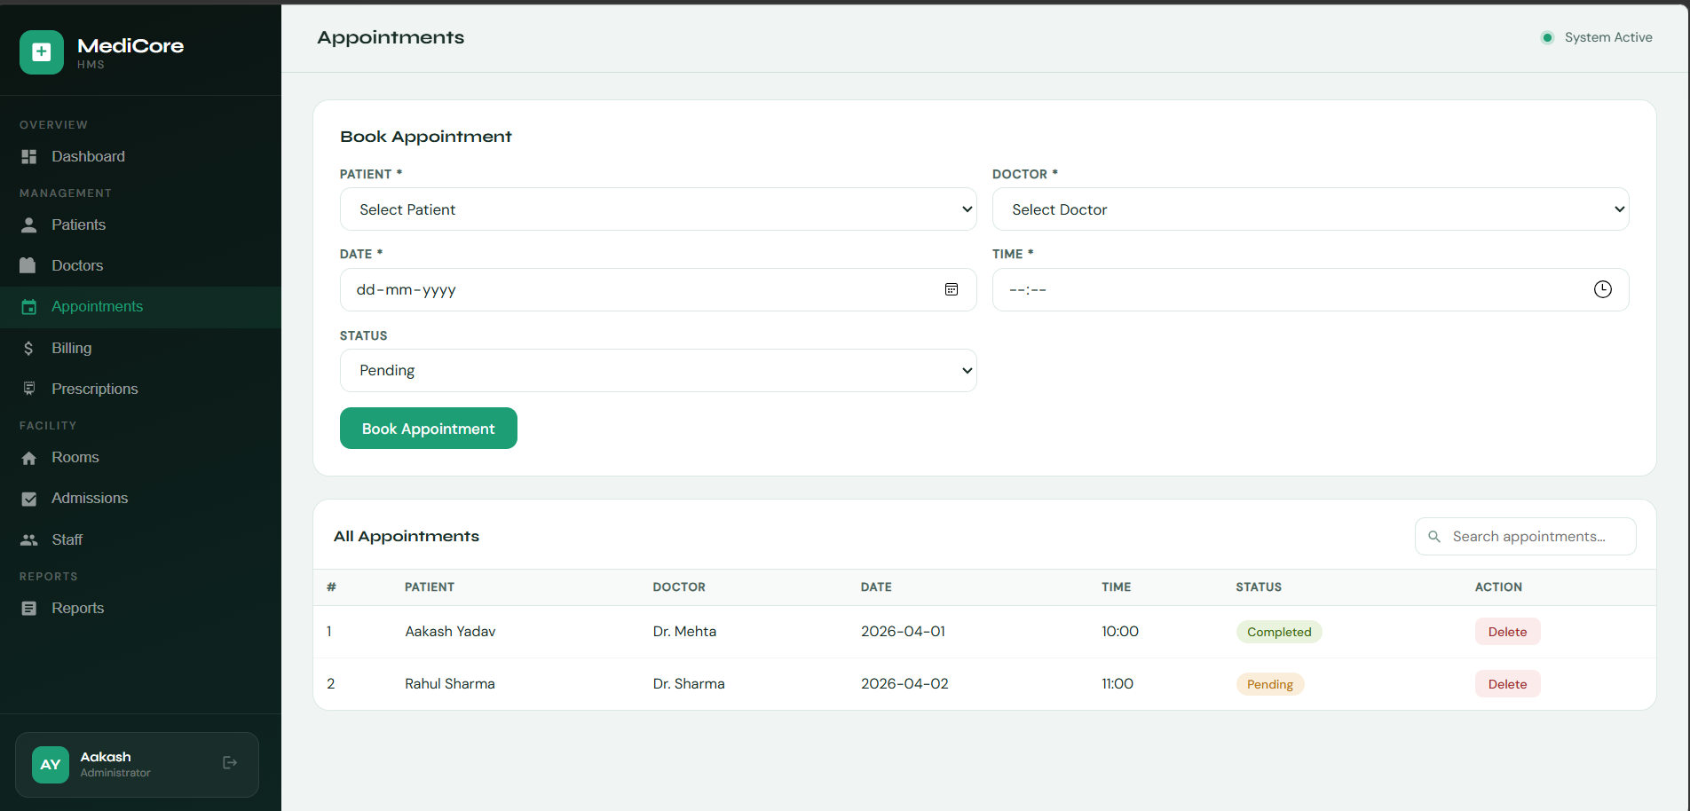
Figure 8.1 — Appointment System showing booking form and appointment records with status badges

9. Website Walkthrough — Billing System

9.1 Billing Module Overview
The Billing System manages all financial transactions within the hospital. Each bill is linked to a patient (FOREIGN KEY) and tracks the total amount and payment status. This module enables the hospital to monitor revenue collected and amounts pending.

Billing Module Features:
- Generate Bill form: Select Patient (dropdown), Enter Total Amount (₹), Payment Status (Paid or Pending)
- Bills table: shows serial number, patient name, total amount in INR, payment status badge, and delete
- Payment status: Green badge for 'Paid', Amber badge for 'Pending'
- Search bar: filter bills by patient name or payment status
- Dashboard shows live revenue summary — total paid vs total pending
- Pending payments section on Dashboard shows individual unpaid bills

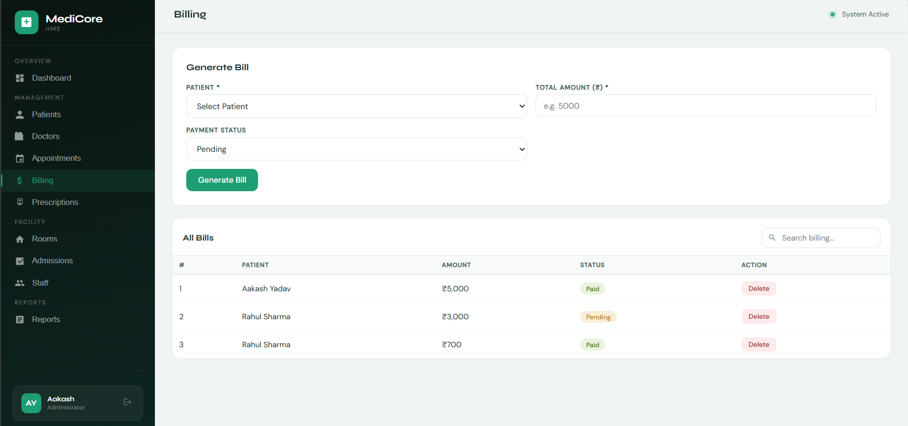
Figure 9.1 — Billing System showing bill generation form and payment tracking table

10. Website Walkthrough — Prescription System

10.1 Prescription Module Overview
The Prescription System connects three database tables in a single operation: patients, doctors, and medicines. This is a classic example of a three-way JOIN in SQL. Doctors prescribe medicines to patients with specific quantities, and all records are stored in the 'prescriptions' table.

Prescription Module Features:
- Add Prescription form: Select Patient, Select Doctor, Select Medicine (from medicines table), Enter Quantity
- All three dropdowns auto-populated from their respective database tables
- Prescriptions table: shows patient, doctor, medicine name, and quantity
- Search bar: filter prescriptions by patient name or medicine name
- Demonstrates a complex 3-table foreign key relationship in the schema

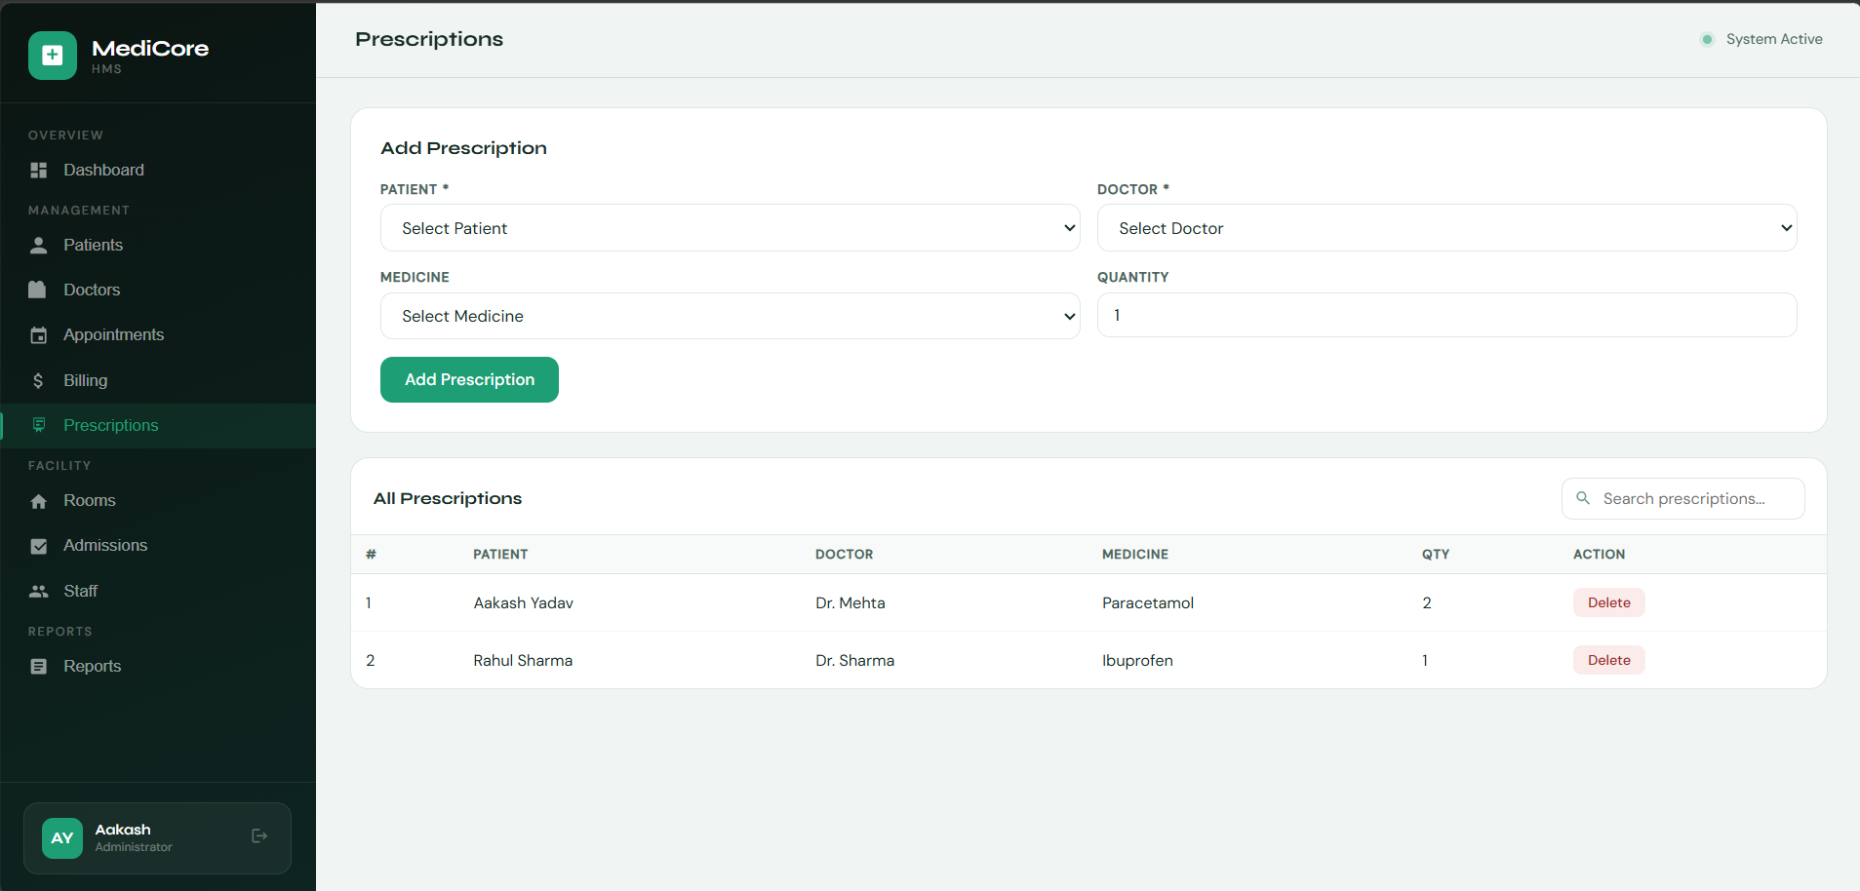
Figure 10.1 — Prescription System showing 3-way linked form and prescription records table

11. Website Walkthrough — Room Management

11.1 Room Module Overview
The Room Management module provides a unique visual grid interface to display and manage hospital rooms. Unlike other modules, rooms are shown as clickable visual cards rather than a table, making it easy to see occupancy status at a glance. Clicking any room card toggles its status between Available and Occupied.

Room Module Features:
- Add Room form: Select Room Type (General/ICU/Private/Semi-Private/Emergency), Set Status
- Visual room grid: each room shown as a card with room number, type, and status
- Color coding: Green (teal) for Available rooms, Red for Occupied rooms
- Click-to-toggle: clicking any room card instantly switches its status
- Search/filter bar: filter rooms by type or status
- Room availability reflected in Admissions dropdown (only Available rooms shown)
- Room occupancy percentage displayed on Dashboard progress bar

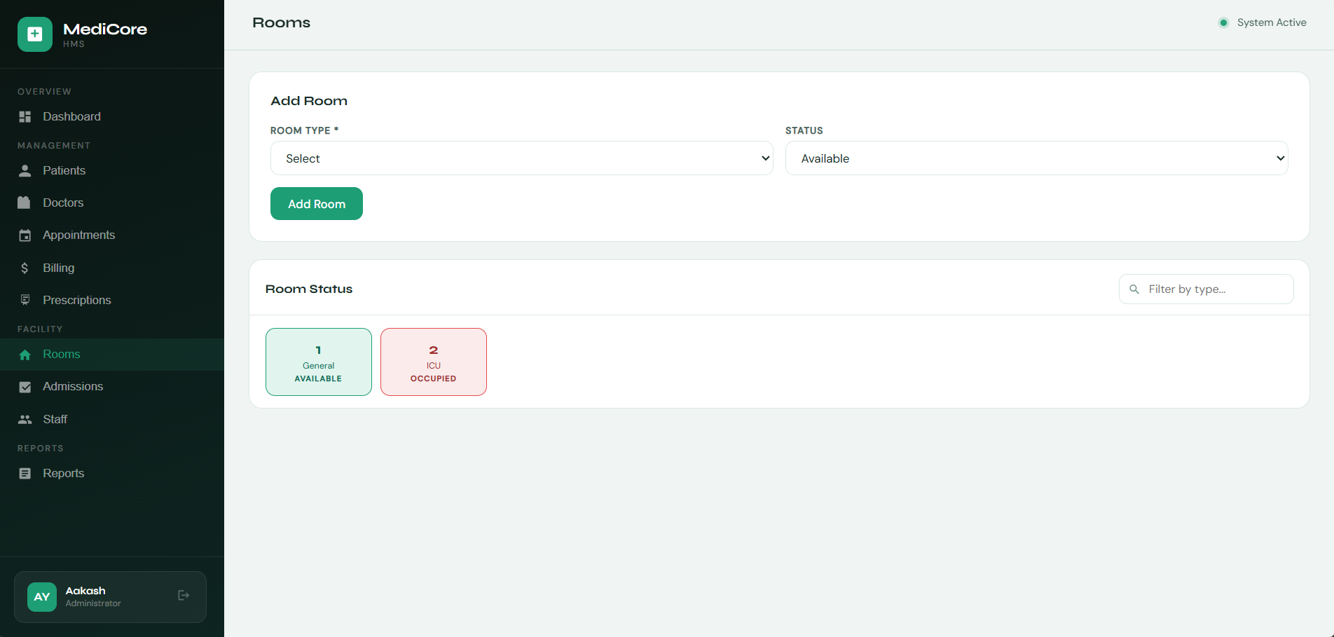
Figure 11.1 — Room Management showing the visual grid with color-coded room status cards

12. Website Walkthrough — Admission Records

12.1 Admissions Module Overview
The Admissions module manages patient hospitalization records. When a patient is admitted to a room, the system creates a record in the 'admissions' table (linking patient_id and room_id) and automatically marks the room as 'Occupied' in the rooms table. Discharge date is optional and shows 'Active' if the patient is still admitted.

Admissions Module Features:
- Admit Patient form: Select Patient, Select Room (only Available rooms shown), Admission Date, Discharge Date (optional)
- On admission, the selected room automatically changes status to 'Occupied'
- Admissions table: shows patient, room with type, admission date, discharge date or 'Active' badge
- Red 'Active' badge shown for patients not yet discharged
- Search bar: filter by patient name or room type
- Demonstrates cascading updates across two related tables

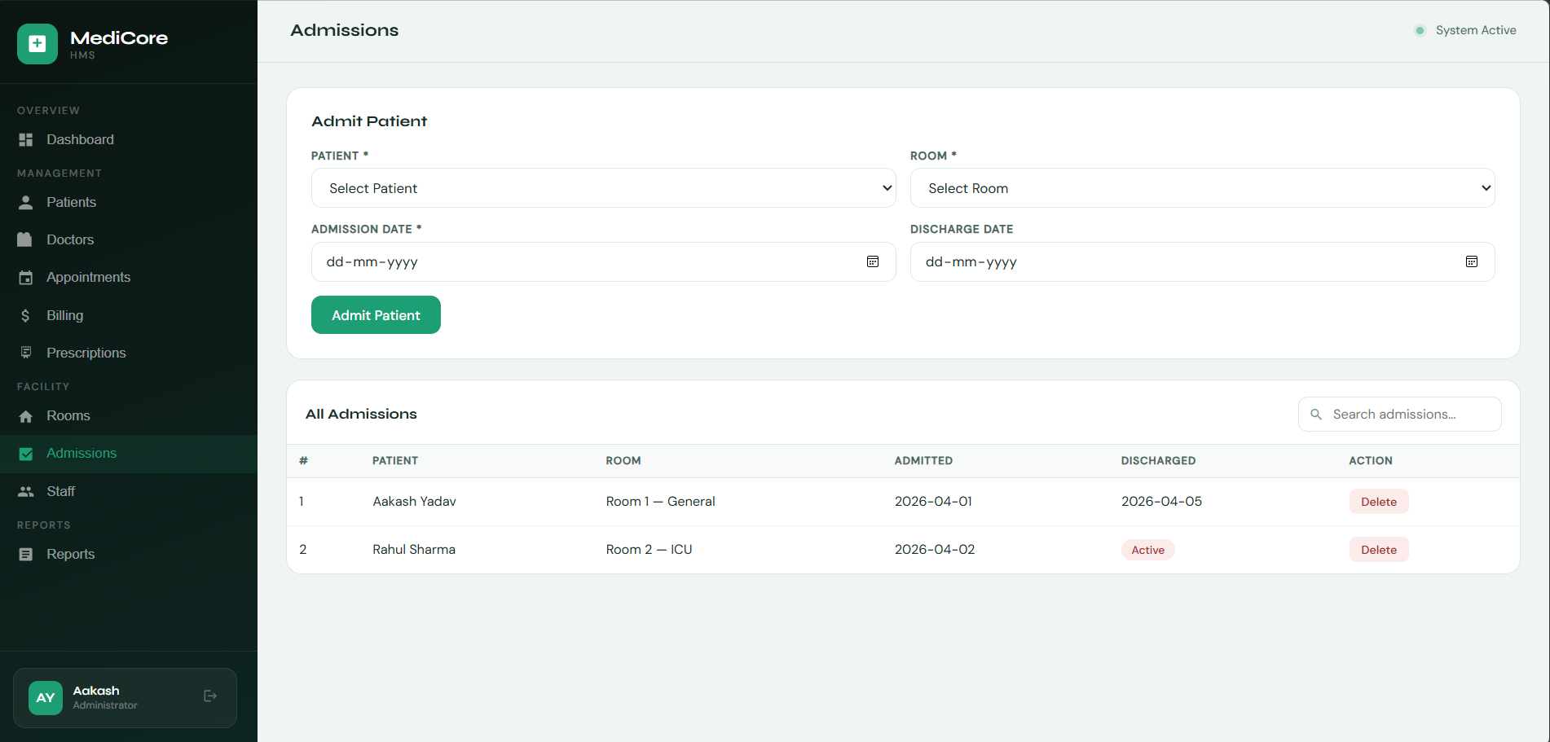
Figure 12.1 — Admissions module showing patient admission form and admission history

13. Website Walkthrough — Staff Management

13.1 Staff Module Overview
The Staff Management module tracks all non-doctor hospital employees. Staff roles include Nurse, Receptionist, Technician, Pharmacist, and Admin. Each role is displayed with a distinct color-coded badge for quick identification.

Staff Module Features:
- Add Staff form: Name, Role (dropdown), Phone number
- Staff table: shows name, role badge with color coding, phone, and delete option
- Role color coding: Teal for Nurse, Blue for Receptionist, Amber for Technician, Green for Pharmacist, Red for Admin
- Search bar: filter staff by name or role
- Staff count shown on Dashboard stat cards

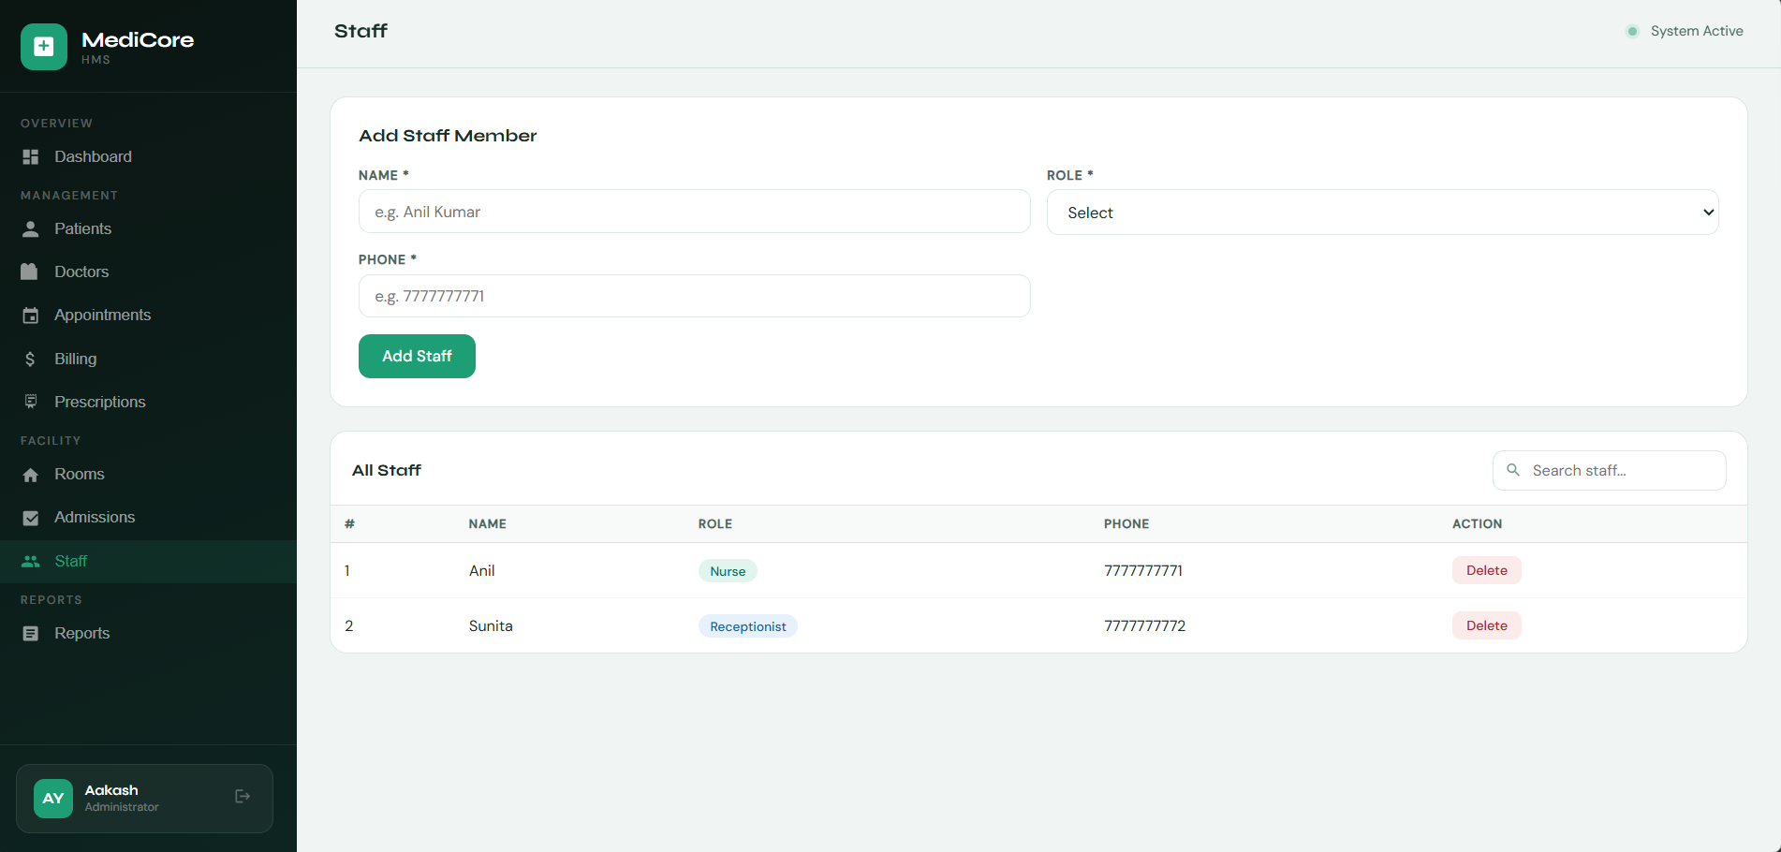
Figure 13.1 — Staff Management showing add form and staff table with role badges

14. Website Walkthrough — Reports & Analytics

14.1 Reports Module Overview
The Reports module is the most data-intensive section of the HMS. It executes 4 key SQL queries simultaneously — the full hospital report (4-table JOIN), appointments per doctor with a visual bar, medicines cost summary, and patients older than 22. This page directly demonstrates the power of SQL JOIN, GROUP BY, and aggregate functions.

Reports Module Features:
- Full Hospital Report (SQL Query #20): 4-table JOIN showing patient name, doctor, appointment date, and bill amount
- Search bar on the full report for filtering results by patient or doctor name
- Appointments per Doctor (SQL #16): bar chart-style visualization showing doctor workload
- Medicines Summary (SQL #13): lists all medicines with prices and shows total cost (SUM)
- Patients Older Than 22 (SQL #14): filters patient records with WHERE age > 22
- All data is live and updates automatically as records are added or deleted

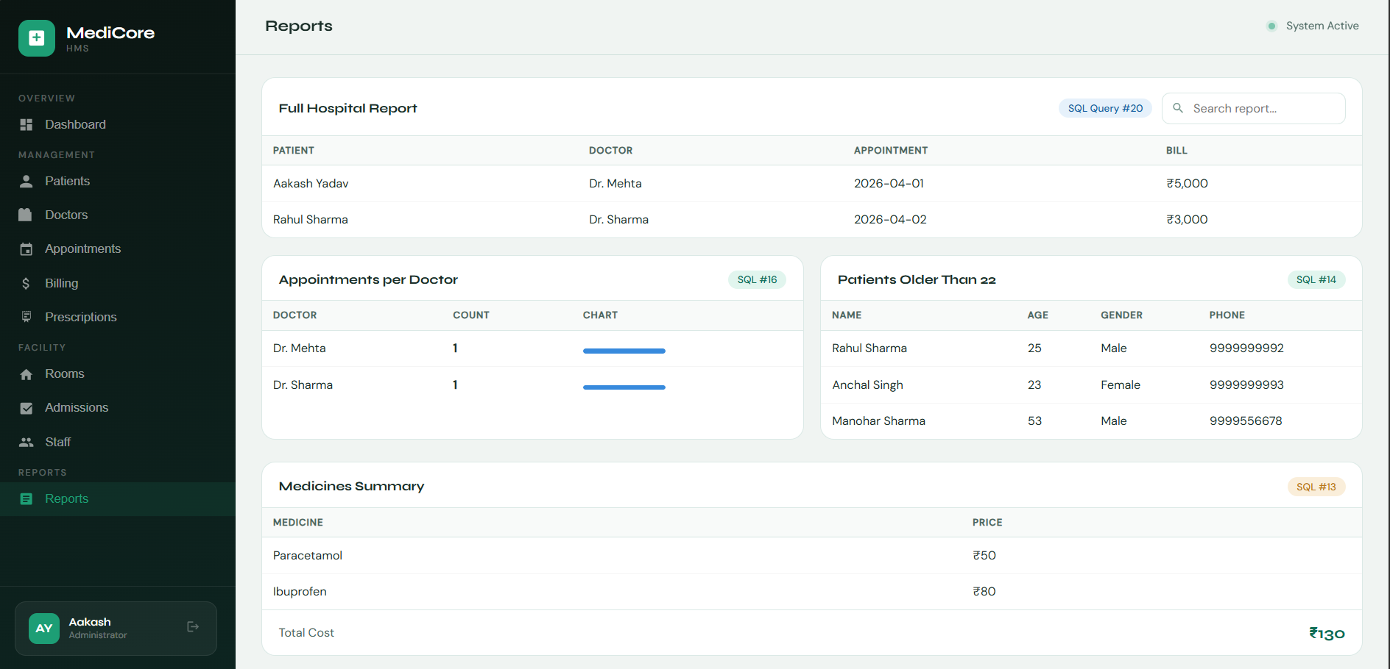
Figure 14.1 — Reports & Analytics page showing the Full Hospital Report, doctor appointment counts, medicines summary, and age filter

14b. Delete Confirmation Modal

Overview
Every delete action across all modules triggers a confirmation modal overlay. This prevents accidental data deletion. The modal appears centered over a dark overlay, prompting the user to either Cancel or confirm the Delete. This is a standard UX safety mechanism.

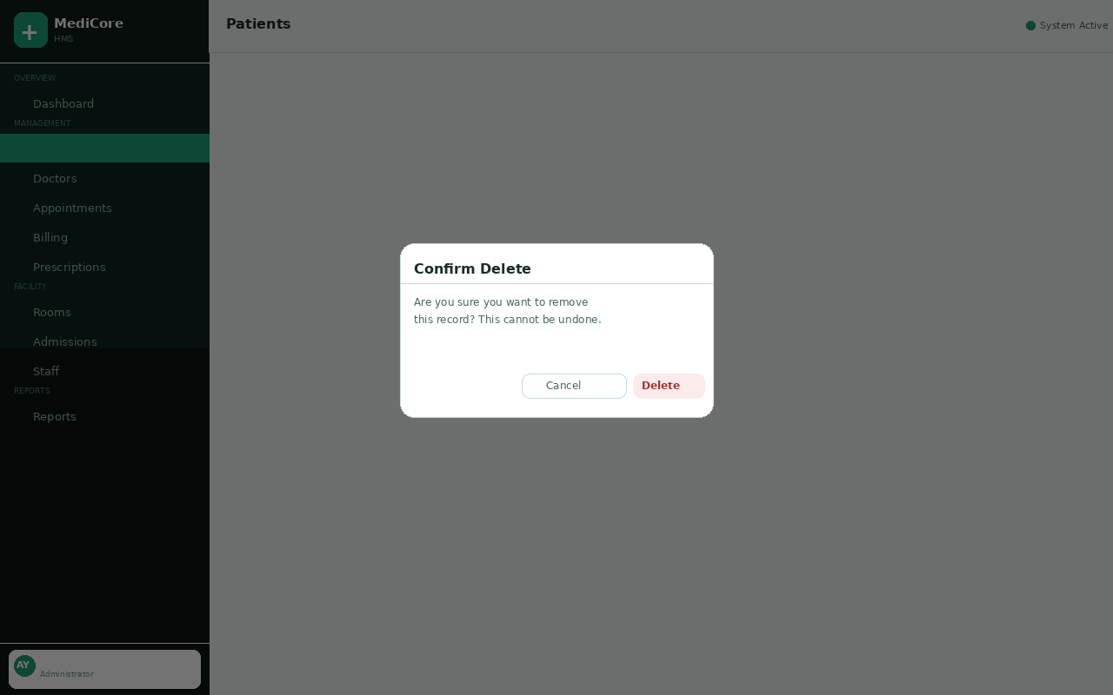
Figure 14b — Delete Confirmation Modal preventing accidental record deletion

15. SQL Queries Reference

All 20 SQL queries implemented in this project are listed below with descriptions and the SQL operations used.

# | Description | SQL Statement
1 | View all patients | SELECT * FROM patients;
2 | View doctors with specialization | SELECT name, specialization FROM doctors;
3 | Patient appointments (JOIN) | SELECT p.name, d.name, a.appointment_date FROM appointments a JOIN patients p ON ... JOIN doctors d ON ...
4 | Total billing per patient | SELECT p.name, b.total_amount FROM billing b JOIN patients p ON b.patient_id = p.patient_id;
5 | Medicines prescribed | SELECT p.name, m.name FROM prescriptions pr JOIN patients p ON... JOIN medicines m ON...
6 | Room status | SELECT * FROM rooms;
7 | Patients admitted in rooms | SELECT p.name, r.room_type FROM admissions a JOIN patients p ON... JOIN rooms r ON...
8 | Doctors in departments | JOIN doctor_department + doctors + departments
9 | Total patients count | SELECT COUNT(*) AS total_patients FROM patients;
10 | Pending payments | WHERE payment_status = 'Pending'
11 | Appointment status count | SELECT status, COUNT(*) FROM appointments GROUP BY status;
12 | Staff roles count | SELECT role, COUNT(*) FROM staff GROUP BY role;
13 | Total medicines cost | SELECT SUM(price) FROM medicines;
14 | Patients older than 22 | SELECT * FROM patients WHERE age > 22;
15 | Available rooms | SELECT * FROM rooms WHERE status = 'Available';
16 | Appointments per doctor | SELECT d.name, COUNT(*) FROM appointments a JOIN doctors d ON... GROUP BY d.name;
17 | Highest billing | SELECT MAX(total_amount) FROM billing;
18 | Latest appointment | SELECT * FROM appointments ORDER BY appointment_date DESC;
19 | Admission details | SELECT * FROM admissions;
20 | Full hospital report | 4-table JOIN: patients + appointments + doctors + billing

16. Setup & Installation Guide

16.1 MySQL Database Setup
- Open MySQL Workbench and connect to your local MySQL server instance
- Run: CREATE DATABASE hospital_db; and USE hospital_db;
- Execute all CREATE TABLE statements (patients, doctors, departments first — to avoid FK errors)
- Run INSERT INTO statements to populate the sample data
- Execute the 20 SELECT queries to verify all data and relationships are working

16.2 Frontend (Website) Setup in VS Code
- Open VS Code and navigate to the project folder
- Install the Live Server extension by Ritwick Dey from the Extensions marketplace
- Right-click on index.html (or hospital_management_system.html) in the file explorer
- Select 'Open with Live Server' — the browser opens at http://127.0.0.1:5500
- Use login credentials: Email — admin@medicore.com | Password — admin123

Default Admin Account
Email: admin@medicore.com
Password: admin123
You can also register a new account using the Sign Up page.

17. Learning Outcomes & Conclusion

17.1 Learning Outcomes
- Designed and implemented a fully normalized relational database with 11 tables following 3NF
- Established proper Primary Key and Foreign Key constraints ensuring referential integrity
- Wrote 20 meaningful SQL queries using SELECT, JOIN, GROUP BY, ORDER BY, WHERE, COUNT, SUM, MAX
- Built a full-stack web application using HTML5, CSS3, and Vanilla JavaScript
- Implemented real-world features: authentication, search, CRUD operations, live stats
- Learned about database normalization (1NF, 2NF, 3NF) and how to eliminate data redundancy
- Understood client-server architecture and how frontend communicates with a backend database
- Practiced UI/UX design principles: responsive layout, color-coded status badges, modal dialogs

17.2 Future Enhancements
Feature | Description
PHP/Node.js Backend | Real server-side MySQL connection replacing localStorage
PDF Report Generation | Download billing receipts and admission reports as PDFs
Email/SMS Notifications | Appointment reminders and payment due alerts
Admin Analytics Charts | Visual pie/bar/line charts for patient trends and revenue
Cloud Deployment | Host on AWS/Azure with live MySQL RDS database
Role-Based Access | Separate portals for Admin, Doctor, Nurse, and Patient
Mobile App | React Native app for doctors to manage appointments on-the-go
AI Symptom Checker | NLP-based symptom analysis to suggest specialist

17.3 Conclusion
The MediCore Hospital Management System project successfully demonstrates a comprehensive, real-world application of Relational Database Management System (RDBMS) principles. By designing 11 normalized tables with proper relational constraints, implementing 20 SQL queries covering JOINs, aggregations, filters, and sorting, and building an interactive web interface — this project bridges theoretical DBMS knowledge with practical software engineering skills.
The inclusion of a complete authentication system, search functionality across every module, visual room management, live dashboard statistics, and a full reporting module makes this project a thorough demonstration of what a production-grade hospital management system would look like in a real healthcare environment.
This capstone project reinforced core skills in database design, SQL querying, web development, and system integration — all essential competencies for a career in software development and data engineering.

Project Created By
Aakash Yadav
B.Tech CSE | KR Mangalam University | DBMS Capstone Project | 2024-2028

